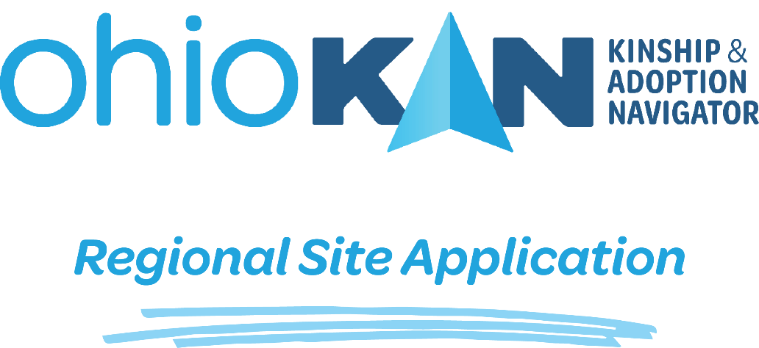

Thank you for your interest in becoming an Ohio Kinship and Adoption Navigator (OhioKAN) site! This introductory section provides an overview of the application process and what happens after you submit your application here. If you have any questions about this process, you can visit our Overview page here: https://ohiokan.jfs.ohio.gov/regional-site-application/

OhioKAN Mission & Values
Kinnect, in partnership with Stakeholders from across the state and the Ohio Department of Job and Family Services, has developed a statewide kinship and adoption navigator program, OhioKAN. The mission of OhioKAN is to provide a statewide, flexible, and responsive kinship and adoption navigator program designed to assist children, caregivers, and families. OhioKAN takes an inclusive, engaging, and genuine approach to partner with families to strengthen their networks. Kinnect and program staff believe that families are inherently capable of finding solutions to the circumstances and challenges they face.

What does it mean to be an OhioKAN site?
Interested community-based, public, and private agencies should complete the application below to be considered to be an OhioKAN program site. Selected applicants will employ a full time OhioKAN Navigator. The Navigators will work with kinship (as defined in R.C. 5101.85) and adoptive families providing support and collaborative services according to the program model to improve family functioning and maintain stability for youth. The sites will receive training, coaching, program materials, technical assistance, and evaluation support provided by Kinnect staff to offer the OhioKAN program in their region. Sites must consistently provide the OhioKAN model to fidelity. Interested applicants should review the “Affirmations” page at the end of this application to see what becoming an OhioKAN site entails.

How do I submit our application?
Once you have completed your application, you can submit your application electronically by visiting our OhioKAN Application portal here: https://ohiokan.jfs.ohio.gov/regional-site-application/

What happens after I submit?
Kinnect staff will review all submitted applications for completeness, making sure full applications move forward in the review process. Kinnect may contact an applicant with missing information to ensure applications are complete.
A review committee of regional stakeholders will be formed to review submitted applications. Reviewers will score the application using a rubric noting alignment with OhioKAN values and goals, and overall agency and program structure. This review committee will remain anonymous but will offer local insight to agency partnerships and presence within the designated region.
The review committee will submit scored applications to Kinnect for final review and decision for OhioKAN sites.

How else will my application be used?
Applications will be used to inform Kinnect and their partners to identify and inform training needs, coaching support, and technical assistance opportunities. Kinnect will support sites to build capacity of implementing organizations to successfully offer OhioKAN to fidelity.

Where can I go if I have additional questions?
If you have questions for how to complete this application, please email roxana.bell@kinnectohio.org or visit our OhioKAN Application Portal: https://ohiokan.jfs.ohio.gov/regional-site-application/

The Application Begins on the Next Page

Step 1: Agency Information
Organization Name:
Organization Point-of-Contact:
Point-of-Contact phone number and email:
Organization address:
County:
Collaborating Organization(s), if Any:
If your application includes formally collaborating with other organization(s)
OhioKAN Regions(s) applying for (map below):
Desired Number of Navigators:
If applying for more than one region, please
indicate how many Navigators per region applying for
Year Organization was founded:
Agency* Budget:
Agency* Staff Size:
Total children/individuals served last program year:
Does your site currently provide kinship or post-adoptive family services?
* if the applying agency is part of a larger organization, please answer these questions as the local site, rather than the larger organization.
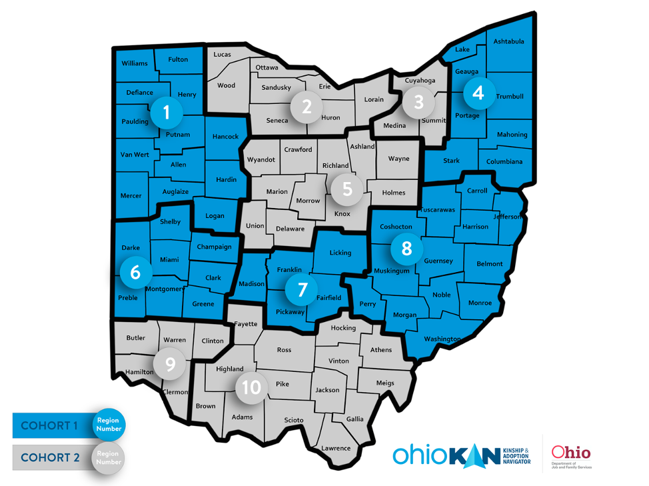

Step 2: Agency Overview
Provide a brief overview of your agency. If your agency is part of a larger state or National organization, share an overview of the entire agency. Include: Mission, values, population served, services provided, etc. (500 word maximum)

Step 3: Program Level
- Why is your organization applying for the OhioKAN program at this time? (300 word maximum)

- Why do you think the OhioKAN program is a good fit for your organization? What about the OhioKAN program is in alignment with your organization’s mission, values? (300 word maximum)

- Please review the attached OhioKAN values: Which of the OhioKAN program values aligns most with your organization/program? (300 word maximum)

- If your agency provides kinship and/or post-adoptive services, describe the types of services provided and how long your organization has been serving those families. If you plan to continue providing these services in addition to OhioKAN, how do you plan to maintain the two while upholding OhioKAN’s core components, structure, and stated requirements*? If you do not provide services to kinship and post-adoptive families, how might OhioKAN align with current services? *Please see the attached Performance Framework for guidance with your response. (500 word maximum)

- In reviewing the Performance Framework please explain how you will adhere to the framework and what supports, if any, you will need to fulfill the objectives and what challenges you foresee, if any. (500 word maximum)

- Where will the OhioKAN Navigator work on a daily basis? Please provide details of the office space they would have, the team they will work with (if applicable), access to internet , supplies, and other necessary work items. If working from home, will navigator be required to come in to pick up supplies, staff meetings, etc.?(300 word maximum)

- Tell us about your strategy for filling the role of the OhioKAN Navigator. At the request of agency, Kinnect may participate in the interview process for navigators. What would this collaboration look like? What strengths, challenges and/or opportunities will you encounter in your effort to recruit someone to fill the role of the OhioKAN Navigator within 45 days of posting? (e.g. union regulations, HR strengths or challenges) (300 word maximum)

Agency Level

- Describe your agency’s general approach to supervision and performance management. How would the OhioKAN Navigator position fit within your agency’s approach to supervision? Is a supervisor currently in place to support Navigator(s) at your agency? (300 word maximum)

- OhioKAN is seeking to enter the federal clearinghouse as an evidence-based kinship program. As such, developing a program that is most effective in meeting the needs of families will require us to collect data on a wide number of indicators. Describe any previous experience your agency has at implementing an evidence-based program. Include which evidence-based programs your agency is currently using. (500 word maximum)

- What concerns/challenges do you have about participating in a statewide program with evaluation? (300 word maximum)

- Navigators are expected to maintain all records within the OhioKAN database. Administratively, the data in the records are used for evaluation, CQI and quality assurance, which is based on a continuous learning and growth mindset for OhioKAN. Describe any previous experience your agency has collecting standardized data, or participating in evaluation, continuous quality improvement, or quality assurance activities. What is your agency’s level of comfort in participating in CQI or program evaluation? (300 word maximum)

- What internal challenges and barriers do you anticipate should your agency be selected as an OhioKAN site? What strategies can be employed to address these challenges? (300 word maximum)

- Does your agency train staff on trauma informed care? If so, please describe which staff receive training, if there is specific model that is trained, how frequently the training is offered, and any other information regarding trauma informed care in the organization? (300 word maximum)
  - Does your agency use a specific evidenced based trauma informed model for working with clients (i.e. Trauma Focused Cognitive Behavioral Therapy, Child-Parent Psychotherapy)? If so, please describe.

- OhioKAN strives to be welcoming and inclusive for all staff and families. To achieve this, we are committed to ongoing Inclusion, Diversity, Equity and Access efforts (IDEA) Describe your organization’s equity efforts, policies and/or activities. In what ways does your organization acknowledge and celebrate diversity, equity, inclusion and promote access for all?

- What salary range would your agency request for your full-time OhioKAN navigator? What will the starting salary be for a navigator at your organization? What is the basis for the minimum salary: what factors and qualifications impact this decision? (100 word maximum)

- What does a successful partnership look like for your organization? What elements would need to be present? (300 word minimum)

- We are excited about having you as a potential partner and would love to know more about your organization! If you have them, please provide the links to your organization website, any articles/publications or social media sites.

Community Level

- In what ways does your organization partner or collaborate with other community and/or governmental organizations (i.e. committee meetings, collaborative projects, MOU’s, shared spaces)? (300 word maximum)

- Give an example of a program or service that your organization provides that requires collaboration with another organization. (300 word maximum)

- Describe how you anticipate collaborating with other sites or distributing Navigators throughout the OhioKAN region to ensure equal access to services for kinship and post-adoptive families. (500 word maximum)

Final Comments

Is there anything else you would like us to know? (300 word maximum)

For Additional Reference

Please find additional information about our program at: https://ohiokan.jfs.ohio.gov

Affirmations
By signing this page, you are affirming your understanding of the minimum requirements an agency must maintain to be in good standing as an OhioKAN Program site. All OhioKAN sites understand and agree to:
- All of the tenants of the OhioKAN Program Values.
- Maintain a full time Navigator who will follow the OhioKAN model and will have no other responsibilities in the agency.
- Adhere to the principles in OhioKAN’s Inclusion, Diversity, Equity and Access framework
- Navigators work an eight-hour shift that will fall within the program operating hours of 8:30-6:30, Monday through Friday. Any and all overtime will be discussed with OhioKAN regional staff prior to approval.
- Navigator(s) maintaining all records in SACWIS, and other data systems as needed, and will not require maintenance of OhioKAN records elsewhere at the agency.
- Allow Navigator(s) and Supervisor to participate in all required OhioKAN trainings and Learning Communities.
- Navigator salary and benefits be paid at the typical rate of other employees in the agency, and that Kinnect will provide a reimbursement payment upon timely receipt of invoice (As noted in the MOU, invoices are due the 5th business day of each month).
- Assume responsibility of all human resources activities of the Navigator, but any disciplinary actions, resignations, and salary adjustments must be communicated to your state and regional OhioKAN leadership.
- Implement the OhioKAN model as developed and maintain fidelity to the model. Any difficulties implementing, maintaining fidelity, or adaptations to the model must be communicated to OhioKAN leadership.
- Willingly participate in evaluation and continuous quality improvement activities, including timely data entry and provision of reports as needed.

By signing below, I agree that my agency will be able to meet these minimum requirements, and that further requirements will be addressed through a contract process if chosen as an OhioKAN site.

Signature Date
Name and Title:

